Healthy Aging Symposium 2019

Thursday, March 14, 2019

Jaglom Auditorium, George S. Wise Senate Building

וְהָדַרְתָּ פְּנֵי זָקֵן (ויקרא פרק י"ט פסוק ל"ב)

“You shall rise before a venerable person
and you shall respect the elderly” (Leviticus 19:32)

Granting elderly people a reasonable quality of life is a personal and professional commitment and one of the basic human values. This is the imperative of the “Healthy Aging” initiative at
Tel Aviv University. Nowadays, as the proportion and impact of older members in society surge, the need to understand the vast phenomena of aging, in both their healthy and unhealthy manifestations, is ever growing.

The elderly person undergoes several simultaneous processes: biological aging, affected by genetics and its random structural changes, adaption to the physical environment, increasing of morbidity load, mental adaption to bodily changes as well as changes in one's role in society. This series of changes occurs in parallel, in different rhythms, dictated by various parameters investigated and defined through ongoing research in different disciplines. Thus, aging is one of the most fascinating, complex and dynamic phenomena.

The necessity of investigating the mechanisms of aging as well as of solving unique old-age problems and mental, physical and environmental needs, is a multidisciplinary challenge that involves a wide array of scientific pursuits. From art and culture to medical, sociological and law sciences, from humanities to engineering, smart cities and cyber security – all these research and technologies should be involved.

The goal of the "Healthy Aging" second symposium is to verify, share, discuss and brainstorm the broadband of the aging phenomena aspects, involving most of the research and development areas. Following the ongoing interest in the first “Healthy Aging” symposium, held in January 2018, this symposium aims to establish an international joint collaborative effort for the benefit and wellbeing of all.

09:00 Welcome & Opening Remarks

Dr. Mira Marcus-Kalish - Director, International Research Collaborations, TAU
Prof. Joseph Klafter - President, Tel Aviv University, TAU
Prof. Yoav Henis - VP for R&D, TAU

09:20 - 10:40 Opening Session:

Chair: Prof. Alan Leshner - Chief Executive Officer, Emeritus, AAAS, and former Executive Publisher, Science, USA

Developing a Policy for an Ageing Population: Examples from the UK
Prof. Sarah Harper - Gerontology, Institute of Population Aging, Oxford University, GB

Do Micro-organisms Have Anything to do with Aging?
Prof. George Weinstock - Evnin Family Chair and Director of Microbial Genomics, Jackson Laboratory for Genomic Medicine, USA

Engineering Personalized Tissue Implants for Regenerative Medicine
Prof. Tal Dvir - Laboratory for Tissue Engineering and Regenerating Medicine
School of Molecular Cell Biology and Biotechnology, Department of Materials Science
& Engineering, Sagol Center for Regenerative Biotechnology, Center for Nanoscience
& Nanotechnology, George S. Wise Faculty of Life Sciences, TAU

Keeping People Healthy with Vaccines for the Aging Society
Dr. Rino Rappuoli - Chief Scientist & Head of External R&D GlaxoSmithKline (GSK) Vaccines

10:40 - 11:00 Coffee Break

11:00 - 12:30 Session II:

Chair: Prof. Mauro Ferrari - President and CEO, Houston Methodist Research Institute, Director, Institute for Academic Medicine at Houston Methodist Hospital, Executive Vice President, Houston Methodist Hospital, USA

Biomarkers for Cognition, Aging and Alzheimer’s Disease
Prof. Ilana Gozes - The Gildor Chair for the Investigation of Growth Factors Department of Human Molecular Genetics and Biochemistry Sackler Faculty of Medicine, TAU

Patient-Centered In Silico Assessment of Health Aging: Imaging and
Beyond
Dr. Michael Morris, MD - Nuclear Medicine, and Internal Medicine, Mercy Medical
Center, Baltimore, MD, USA

Medical Epistemology: A Gerontologist's Perspective
Prof. John Sorkin - Chief, Biostatistics and Informatics, University of Maryland
School of Medicine Division of Gerontology and Geriatric Medicine Baltimore VA
Medical Center
Modelling and Optimization of Homecare and Caregiving Services
for the Elderly
Prof. Theng Yin Leng - Professor & Director, Wee Kim Wee School of
Communication & Information, Acting Executive Director, Ageing Research Institute
for Society and Education (ARISE), President's Office, Nanyang Technological
University (NTU)

12:30 - 13:30 Lunch

13:30 - 15:00 Session III:

Chair: Prof. Dov Shmotkin - School of Psychological Sciences, and Head of the Herczeg Institute on Aging, TAU

Protecting the Elderly and Frail from Pressure Ulcers Using Innovative
Bioengineering Technologies
Prof. Amit Gefen - The Herbert J. Berman Chair in Vascular Bioengineering, Department of Biomedical Engineering, Iby and Aladar Fleischman Faculty of Engineering, TAU
Healthy Aging and Filial Piety in the Shadow of the Law
Prof. Daphna Hacker - The Buchmann Faculty of Law, TAU

The Social Shaping of Uncertainty in Length of Life
Dr. Isaac Sasson - Department of Sociology and Anthropology and the Herczeg
Institute on Aging, TAU

Assistive Technology for Cognitive Impaired Seniors in Nursing Homes
Kelvin Tan Cheng Kian - Director, NUS Smart Systems Institute National University
of Singapore

15:00 - 15:30 Coffee Break

15:30 - 17:30 Session IV:

Chair: Dr. Dévora Grynspan - Vice President for International Relations, Northwestern University

Research Directions in Healthy Aging in the Era of the Longevity Economy
Dr. Dana Burr Bradley - Dean, Erickson School of Aging Studies, Professor of Social Gerontology, UMBC

Healthy Aging Starts Not at 65 but at Day One, So Why Do We Misplace
Our Resources?
Prof. Manuel Trajtenberg - The Eitan Berglas School of Economics, TAU and Samuel Neaman Institute, Technion

Healthy Aging International Initiative – Panel Discussion
Prof. Theng Yin Leng - NanYang Technology University, Singapore
Kelvin Tan Cheng Kian - National University of Singapore
Dr. Hedva Voliovitch - Executive Manager, former Head of Global Patient
Safety & Pharmacovigilance, Teva Pharmaceuticals
Miri Polachek - CEO, Joy Ventures, Israel
2019 JOY ACADEMIC GRANT CALL FOR PROPOSALS

18:00 Cocktail Event at the Porter School of Environmental Studies

Speaker Biographies
(in order of appearance)

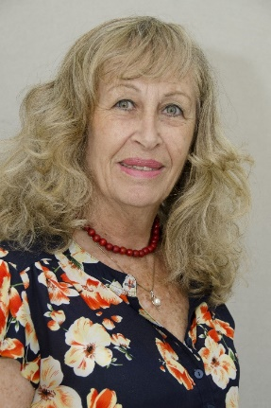
Dr. Mira Marcus-Kalish is the Director of International Research Collaborations at Tel Aviv University. Her main areas of interest are mathematical modelling, converging technologies and data mining.

Dr. Kalish holds a Ph.D. in Operations Research from the Technion, Israel Institute of Technology, where she developed one of the first computerized systems for electrocardiogram (ECG) diagnosis. Her postdoctoral training was at Harvard University, the MBCRR (Molecular Biology Computer Research and Resource) laboratory and at the Dana Farber Cancer Institute. She was awarded her B.Sc. is in Statistics and Biology from the Hebrew University of Jerusalem.

Upon her return to Israel, she joined the Tel Aviv University Business School, establishing the pioneering Medical Management program focusing on Medical Informatics. Dr. Kalish later joined the Weizmann Institute of Science, working with Prof. Ephraim Katzir on protein interactions, specificity and sensitivity. She moved back to Tel Aviv University to the Biotechnology Department, taking active part in cross disciplinary research, Converging Technologies and contributing to the EU-US Wtec-NBIC2 activities and publication.

In the private sector, Dr. Kalish served as the scientific advisor and then the head of the Enterprise Marketing Department of IBM Israel. She played an active role in many EU framework projects such as the Nano2Life Network of Excellence, SkinTreat, ReNaChip, EpoCan, NanoAthero, GLAM, ENATRANS etc. Currently she is the Vice Chair of the Medical informatics of the HBP-the Human Brain Flagship Project. Her focus is on the disease signature identification based on targeted analysis of the micro and macro environmental clinical & scientific knowledge and data. The newly-developed approach and analytical tools are trying to meet the challenges of big versus small data analysis originated in various data sources, towards reliable, personalized and precise medicine.

Other areas of research include rehabilitation of the discrete sensory motor, learning function, drug toxicity, data mining, and, most recently, a broad band project on healthy aging.

Dr. Kalish was one of the researchers that established the Dead Sea Research Institute to utilize this unique region as a “lesson from nature” from natural selection and evolution to survival and human culture. A lesson yielding translational research for the benefit of the planet and humanities.

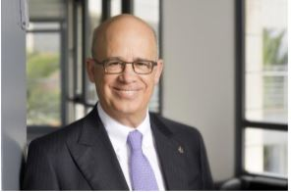

Prof. Joseph Klafter was named President of Tel Aviv University in 2009, the eighth since TAU’s founding in 1956. Widely recognized in his field, chemical physics, he served as Chairman of the Israel Science Foundation (ISF), the main institution supporting scientific research in Israel, from 2002 to 2009.

Prof. Klafter has published close to 400 scientific articles, edited 18 books and is the co-author of First Steps in Random Walks: From Tools to Applications (Oxford University Press, 2011). He has been a member of the editorial boards of numerous scientific journals and a member of the scientific committees of dozens of conferences.
In 2011, The American Academy of Arts and Sciences elected him an honorary member, and he is also a fellow of the American Physical Society. Professor Klafter has won many prestigious prizes in his field, including the Alexander von Humboldt Foundation Prize, the Weizmann Prize for Sciences, the Rothschild Prize in Chemistry, and the Israel Chemical Society Prize. He holds an honorary doctorate from Wroclaw University of Technology, Poland; received the “Commander of the Order of the Star of Italy” distinction from the President of Italy; was awarded an Honorary Professorship of Tsinghua University, China; and most recently received an honorary doctorate from the Slovak Academy of Sciences.

Prof. Klafter completed his BSc and MSc in physics at Bar-Ilan University, and his PhD in chemistry at Tel Aviv University. After post-doctoral studies in chemistry at MIT, he joined the research and engineering division of Exxon in the US, where he worked for eight years. He joined the TAU Raymond and Beverly Sackler School of Chemistry in 1987, and was promoted to full professor in 1989. From 1998 to 2003 he was the incumbent of the Gordon Chair in Chemistry, and from 2003 onward he has held the Heineman Chair of Physical Chemistry. In January 2017, he was appointed Chair of the Committee of University Heads of Israel (“VERA”).

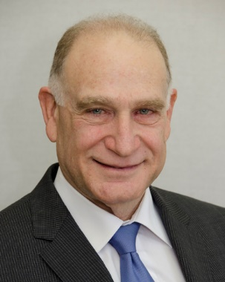
Prof. Yoav Henis is Vice President for Research and Development at Tel Aviv University. In 1974 received his B.Sc. cum laude after completing his studies in chemistry and biochemistry at the Hebrew University. In 1978 he completed his doctoral thesis (direct course for Ph.D.) summa cum laude at the Hebrew University, under the guidance of Prof. Alexander Levitzki. His thesis won the Hebrew University Kennedy-Lee Prize for best thesis of the year. Between 1978 and 1981 he was a post-doctoral fellow (supported by a Chaim Weizmann Fellowship from the Weizmann Institute) under the guidance of Prof. Elliot Elson, first at Cornell University (Ithaca, NY) and then at the Washington University School of Medicine (St. Louis, MO). Upon his return to Israel in 1981 he became a faculty member at the Department of Biochemistry, and then the Department of Neurobiology in the George S. Wise Faculty of Life Sciences at Tel Aviv University.

Prof. Henis has held visiting scholar positions at the Whitehead Institute of M.I.T. in Cambridge, MA (1987-8, 1992-3, 1998-9), the Lawrence Berkeley National Laboratory in Berkeley, CA (2003-4), and the Duke University Medical Center in Durham, NC (2009-10).

Prof. Henis has served as: Head of the Admissions Committee for undergraduate students to the Faculty of Life Sciences (1985-7); Secretary of the Israel Society for Cell Biology (1991-5); Head of the Department of Neurobiochemistry (today named Neurobiology) (1995-8); and was a member of many university and national committees.

Prof. Henis is a leader in the field of cancer biophysics. His research and studies combine cell biology with membrane biophysics to elucidate, in live cells, the action mechanisms of cancer-related proteins. These studies, which deal with the growth-inhibitory transforming growth factor-β receptors and with oncogenic proteins such as Ras and Src, were published in scientific journals of high standing. He is active in scientific organizations in Israel and the USA, and was a member of numerous committees and scientific forums of the Israel Science Foundation and other scientific foundations in Israel. He has won prizes and fellowships from the Bat-Sheva de Rothschild Foundation, the International Union Against Cancer, and the Jacqueline Seroussi Memorial Foundation Award for Cancer Research.

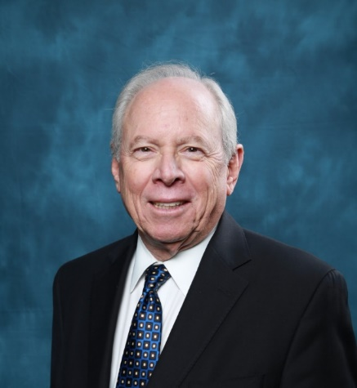

Alan I. Leshner, Ph.D., is Chief Executive Officer, Emeritus, of the American Association for the Advancement of Science (AAAS) and former Executive Publisher of the Science family of journals. Before joining AAAS, Dr. Leshner was Director of the National Institute on Drug Abuse at the National Institutes of Health in the United States. He also served as Deputy Director and Acting Director of the National Institute of Mental Health, and in several roles at the National Science Foundation.

Before joining the government, Dr. Leshner was Professor of Psychology at Bucknell University. He is an elected fellow of AAAS, the American Academy of Arts and Sciences, the National Academy of Public Administration, and many others. He is a member and served as Vice Chair of the governing Council of the National Academy of Medicine (formerly the Institute of Medicine) of the National Academies of Sciences, Engineering and Medicine. He served two terms on the National Science Board, appointed first by President Bush and then reappointed by President Obama.

Dr. Leshner received his Ph.D. and M.S. degrees in physiological psychology from Rutgers University and an A.B. in psychology from Franklin and Marshall College. He is the recipient of many honors and awards, including the Walsh McDermott Medal from the National Academy of Medicine and seven honorary Doctor of Science degrees.

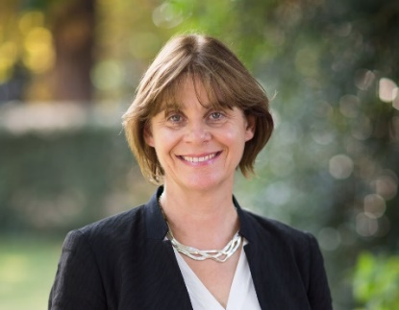
Prof. Sarah Harper is Professor of Gerontology at the University of Oxford. She is the Co-Director of the Oxford Institute of Population Ageing which she founded in 1997 with funding from the NIA. Between 2014 and 2017 Sarah served on the Prime Minister’s Council for Science and Technology, which advises the Prime Minister on the scientific evidence for strategic policies and frameworks. In 2017 she was appointed Director of the Royal Institution of Great Britain, and as a Director and Trustee of the UK Research Integrity Office. She chaired the UK government’s Foresight Review on Ageing Populations,(2014-2016) and has chaired the European Ageing Index Panel for the UNECE Population Unit since 2015. She is a Governor of the Pensions Policy Institute. Sarah was the first holder of the International Chair in Old Age Financial Security, at the University of Malaya (2009-10) and her research was recognized by the 2011 Royal Society for Public Health: Arts and Health Research Award. She is a Fellow of the Royal Anthropology Institute and of the Royal Society of Arts.

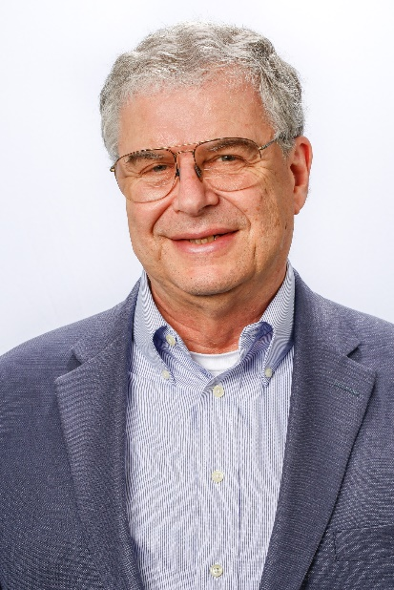

Dr. George Weinstock is the Evnin Family Chair, Professor and Director of Microbial Genomics at the Jackson Laboratory for Genomic Medicine where he established a group devoted to genomic studies of infectious diseases and the human microbiome. The group collaborates extensively with clinicians to apply genomic analyses to a wide range of medical problems. The goal of the metagenomics project is to determine the role of the microbiome in health and disease with the aim of providing both new mechanistic understanding as well as new diagnostic and therapeutic approaches. Dr. Weinstock’s group has played a leading role in the NIH Human Microbiome Project, both Phase 1 and 2, with both basic science and clinical studies, and his current research follows on those themes.

Dr. Weinstock has worked in genomics and microbiology for over 40 years. Previously, he was the co-director of the Human Genome Sequencing Center at Baylor College of Medicine in Houston where he was one of the leaders of the Human Genome Project. He also directed a number of human and mammalian genetics projects aimed at determining genetic causes of conditions such as retinitis pigmentosa, cleft lip, susceptibility to infection, and the role of host genetics in control of the microbiome. He has also been an innovator in methods for microbial genetics, application of DNA sequencing in genomics, and software for genome analysis, as well as medical and agricultural applications of genomics. His research continues evolving with new issues in DNA sequencing technology.

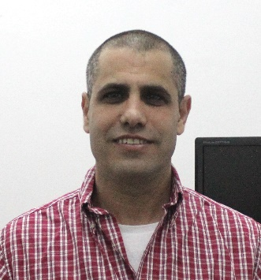
Prof. Tal Dvir is an Associate Professor at Tel Aviv University. He received his B.Sc. (2003) and Ph.D. (2008) degrees from the faculty of Engineering at Ben-Gurion University of the Negev. His Ph.D. research focused on cardiac tissue engineering and regeneration. Dvir continued his postdoctoral studies in the laboratory of Prof. Robert Langer in the Department of Chemical Engineering at MIT. His postdoc research focused on advanced materials for tissue engineering and regeneration. In October 2011, he was recruited by the Department of Biotechnology and the Center for Nanotechnology at Tel Aviv University to establish the Laboratory for Tissue Engineering and Regenerative Medicine. In 2013, Prof. Dvir joined the newly-established Department of Materials Science and Engineering at Tel Aviv. Currently, his laboratory designs and develops smart bio and nanomaterials and technologies for engineering complex tissues, such as the heart, brain, spinal cord, intestine and eye.

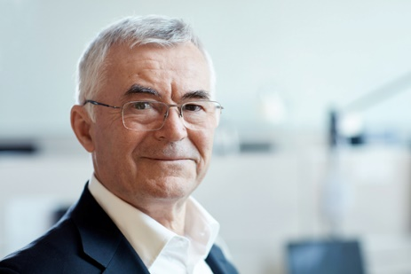

Dr. Rino Rappuoli is Chief Scientist and Head of External R&D at GSK Vaccines, based in Siena, Italy and Professor at Imperial College, London, UK. Prior positions include Head of Vaccine R&D at Novartis, CSO of Chiron Corporation, and Head of R&D at Sclavo. He obtained his PhD in biological sciences at the University of Siena, Italy, and has been a visiting scientist at both Rockefeller University and Harvard Medical School in the United States.

He is an elected member of US National Academy of Sciences (NAS), the American Academy of Arts and Sciences (AAAS), the European Molecular Biology Organization (EMBO), and the Royal Society of London. Dr. Rappuoli has received numerous awards including the Gold Medal of the Italian President, the Albert B. Sabin Gold Medal, the Canada Gairdner International Award, and the European Inventor Award for Lifetime Achievement. A few years ago, he was nominated as the third most influential person worldwide in the field of vaccines (Terrapin). He has published 680 works in peer-reviewed journals.

Dr. Rappuoli has developed and implemented a number of novel scientific concepts critical for vaccine development in the areas of genetic detoxification, cellular microbiology, reverse vaccinology and the pangenome. With others, he has developed several licensed vaccines and related adjuvants/carriers. These include: the acellular pertussis vaccine, which contains a non-toxic mutant of pertussis toxin; the first conjugate vaccine against meningococcus C; MF59, the first vaccine adjuvant after aluminium salts, which stimulates production of CD4 memory cells following meningococcal B vaccination; and CRM 197, a non-toxic mutant of diphtheria toxin that is used as carrier protein for polysaccharides and haptens to make them immunogenic in conjugate vaccines for several diseases, including meningococcal and pneumococcal infections. Recently he used a genome-based approach, named reverse vaccinology, to discover antigens for a new vaccine against meningococcus B. Dr. Rappuoli is among the world scientific leaders dedicated to the sustainability of global health.

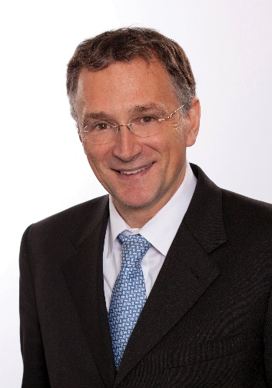

Mauro Ferrari, Ph.D, is the former president of the Houston Methodist Institute for Academic Medicine and chief commercialization officer for Houston Methodist. He currently serves as a director on the board of Arrowhead Pharmaceuticals and is involved in research, education and service to the underprivileged.

Dr. Ferrari has served in his leadership roles since 2010 and brought national acclaim to the Houston Methodist Research Institute. Under his leadership, Houston Methodist recruited some of the world’s most preeminent scientists and conducted impactful research focused on patient care with a goal of moving solutions from the bench to the bedside as quickly as possible.

Dr. Ferrari is considered a pioneer of biomedical nano/micro-technology, especially as they relate to drug delivery, cell transplantation and implantable bioreactors. He has to his credit more than 450 publications, including seven books and is the inventor of 46 issued patents in the U.S. and Europe. Dr. Ferrari has served as the Editor-in-Chief for “Biomedical Microdevices: BioMEMS and Biomedical Nanotechnology” since 1997. He was a principal investigator on multiple large grants from the National Cancer Institute and the Department of Defense.

His contributions to the field of biomedical nanotechnology have been recognized through numerous awards and accolades, including: Founders Award − Controlled Release Society, the Wallace H. Coulter Award for Biomedical Innovation and Entrepreneurship, the ETH Zürich Stodola Medal, Blaise Pascal Medal in Biomedical Engineering − European Academy of Sciences, and the Shannon Director's Award of the National Institutes of Health.

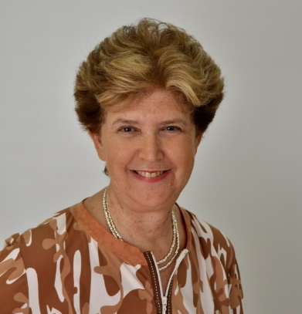

Prof. Ilana Gozes is the Lily and Avraham Gildor Chair for the Investigation of Growth Factors at Tel Aviv University. At the Sackler Faculty of Medicine, Prof. Gozes heads the Dr. Diana and Zelman Elton (Elbaum) Laboratory for Molecular Neuroendocrinology (including ~10 staff members) at the Department of Human Molecular Genetics and Biochemistry, also affiliated with Sagol School of Neuroscience and the Adams Super Center for Brain Studies.

Prof. Gozes is the Editor-in Chief of the Journal of Molecular Neuroscience. Among other things, Prof. Gozes heads the Tel Aviv Chapter of the Society for Neuroscience, is an Associate Editor for the Journal of Alzheimer's Disease and a member of the Editorial Advisory Panel and Editorial Board of Scientific Reports (Nature), an Ex-President of the Israel Society for Neuroscience (ISFN) and Past Director of the Adams Super Center for Brain Studies. She was the Founding Scientist and a Director at Allon Therapeutics Inc. in Vancouver, Canada and is currently the Chief Scientific Officer of Coronis Neurosciences.

Prof. Gozes (BSc, Tel Aviv University, PhD, Weizmann Institute of Science, postdoctoral fellow at Massachusetts Institute of Technology (MIT), research associate/visiting scientist, Salk Institute and the Scripps Clinic and Research Foundation) was a Senior Scientist/Associate Professor at the Weizmann Institute and a Fogarty Scholar-in-Residence at the National Institutes of Health (NIH, USA). Prof. Gozes has published ~300 papers, in the fields of neuroscience and is cited >13000 times (H index 61). Professor Gozes received many prizes (including the Teva award, the Landau Prize and the Humboldt Award) for her pioneering work on nervous system function, from genes to behavior and drug development. Some of her propriety inventions are in clinical development.

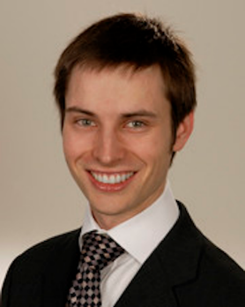
Dr. Michael Morris completed his training in diagnostic radiology and nuclear medicine at the University of Maryland Medical Center after completing his internship in internal medicine at the Mercy Medical Center and upon completion of his medical training at the University of Maryland School of Medicine. Prior to medicine, he completed his M.Sc. in molecular and cellular biology at Johns Hopkins University, where he also completed his B.Sc. in the same discipline. Dr. Morris’ clinical interest is primarily in oncoradiology involving whole body imaging and nuclear imaging using PET, CT and MR modalities for patients with oncology. He serves on the medical staff for diagnostic radiology, nuclear medicine, and internal medicine at Mercy Medical Center, a private, academic-affiliated hospital and large cancer referral center for the state of Maryland and surrounding regions. In addition to his clinical work, Dr. Morris serves as President for the healthcare research and policy non-profit, Networking Health. His academic interests are primarily in quantitative imaging and imaging informatics with various projects at his host institution, and in collaboration with the National Institutes of Health, Baltimore VA Medical Center, UMBC, Johns Hopkins University, among other academic, research, and industry organizations.

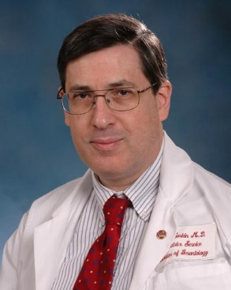
Dr. John Sorkin is a physician, epidemiologist, and statistician who, for more than three decades, has analyzed biomedical data, worked on clinical trials, and taught. He has published more than 150 articles and book chapters. He is a Professor in the Department of Medicine, University Maryland Baltimore; and in the Department of Epidemiology and Public Health, University Maryland Baltimore. He is an Affiliate Professor in the Department of Epidemiology and Biostatistics, University Maryland College Park; and Affiliate Professor in the Department of Computer Science and Electrical Engineering, University of Maryland, Baltimore County. Prior to medical school, he worked in the field of, and taught, computer science in both academia and industry.

For the last 19 years, he has been Principal Investigator of the (1) Biostatistics Core of the University of Maryland’s Claude D. Pepper Older Americans Independence Center, and of the (2) Biostatistics Core of the Baltimore Veterans Affairs Medical Center’s Geriatrics Research, Education, and Clinical Center; and since their inception twelve years ago has been PI of the Biostatistics Core of the (3) Veterans Affairs Maryland Exercise and Robotics Center of Excellence and the (4) Bio-statistics Subcore of the University of Maryland’s Mid-Atlantic Nutrition Obesity Research Center. He is a member of the Editorial Board of, and statistical reviewer for, the American Journal of Clinical Nutrition, was co-editor of Diabetes Metabolism Research and Reviews. His research explores risk factors for, and interventions designed to lower risk for diabetes, cardiovascular disease, obesity and mortality and the genetics of longevity and interventions designed to promote recovery from chronic disease in older adults.

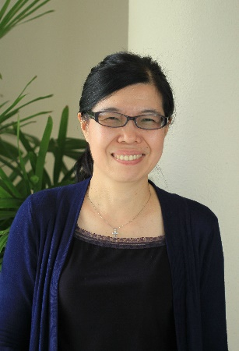

Dr. Theng Yin Leng is Professor and Acting Executive Director at the Ageing Research Institute for Society and Education at Nanyang Technological University. She is the Founding Director of the Centre of Healthy and Sustainable Cities (CHESS) and Professor at the Wee Kim Wee School of Communication and Information. She is also Research Director for Arts, Humanities, Education and Social Sciences at the Research Strategy and Coordination Unit (President’s Office), Nanyang Technological University (NTU, Singapore).

In the area of research, Prof. Theng’s philosophy is about doing worthwhile, scientifically-based experimental Human-Computer Interaction in understanding users and their interactions, especially for Information Systems, in her earlier research on the World Wide Web and Digital Libraries, and with recent focus on interactive systems/devices for Healthcare and Education. Her main research interest is to develop innovative tools, techniques, methods and models to assist in the design and evaluation of interactive systems/devices, making research relevant and impacting society.

Dov Shmotkin, PhD, is Professor Emeritus in the School of Psychological Sciences and Head of the Herczeg Institute on Aging, both at Tel Aviv University. He is a senior clinical psychologist and formerly the head of the clinical psychology graduate program. He has been engaged in gerontological research on developmental and aging processes with a focus on their relations with physical and mental health along adulthood and old age. His current research establishes his conceptual model on the pursuit of happiness in the face of adversity. He investigated interrelations of biographical experiences (e.g., trauma) with self-conception systems, mainly subjective well-being and meaning in life. He explored how personal time perspective shapes effects of one’s life experiences, and examined individuals’ images of present and future threats as jointly formulating the notion of hostile-world scenario.

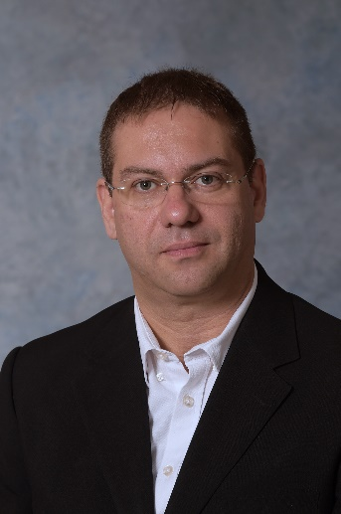

Prof. Amit Gefen received his B.Sc. in Mechanical Engineering and M.Sc. and Ph.D. in Biomedical Engineering from Tel Aviv University in 1994, 1997, and 2001, respectively. During 2002-2003 he was a post-doctoral fellow at the University of Pennsylvania, USA. He is currently a Full Professor with the Department of Biomedical Engineering at the Faculty of Engineering of Tel Aviv University and the Herbert J. Berman Chair in Vascular Bioengineering. The research interests of Prof. Gefen are in studying normal and pathological effects of biomechanical factors on the structure and function of cells, tissues and organs, with emphasis on applications in chronic wound research. In 2007-2008 he was a visiting scientist at Eindhoven University of Technology in the Netherlands, where he developed tissue-engineered model systems to study pressure ulcers.
To date, Prof. Gefen has published more than 200 articles in peer-reviewed international journals, many of which on mechanobiology, cell and tissue biomechanics, with applications that are mostly in chronic wound prevention. He was awarded the best paper awards by journals such as Medical & Biological Engineering & Computing and Medical Engineering & Physics. He is the Editor-in-Chief of Clinical Biomechanics (published by Elsevier), and has also edited several books (published by Springer and others), and several Special Issues in journals such as the Annals of Biomedical Engineering, Journal of Biomechanics, Computer Methods in Biomechanics and Biomedical Engineering and more. He is also editing a book series on Mechanobiology, Tissue Engineering and Biomaterials (published by Springer), and has served as an Associate Editor or at Editorial Boards of several international journals which are ranked at the top of his field, e.g. PLoS One, the Annals of Biomedical Engineering, the Journal of Biomechanics, Medical Engineering & Physics, Computer Methods in Biomechanics and Biomedical Engineering, Journal of the Mechanical Behavior of Biomedical Materials, the Journal of Tissue Viability, Ostomy Wound Management and the Journal of Wound Care, to mention a few. In 2015, he was awarded the Editorial Excellence Award by the Annals of Biomedical Engineering and the Biomedical Engineering Society in the USA.

Prof. Gefen has been the President of the European Pressure Ulcer Society (the European Pressure Ulcer Advisory Panel, EPUAP, www.epuap.org) in 2013-2015. He is a member of the World Council of Biomechanics and a Fellow of the International Academy of Medical and Biological Engineering and the European Alliance for Medical and Biological Engineering. Prof. Gefen was awarded the Pressure Care career award by the World Union of Wound Healing Societies in 2016, the Experienced Investigator Award of EPUAP in 2017 and the Otto Schmitt Career Award of the International Federation of Medical & Biological Engineering (IFMBE) in 2018 for “exceptional contributions to the advancement of the field of medical and biological engineering”. Prof. Gefen had visiting professorship appointments and fellowships in multiple UK universities including Cambridge University (the Isaac Newton Institute), University of Southampton (Distinguished Fellowship through the Royal Academy of Engineering) and the University of Huddersfield, as well as at the University of Cape Town in South Africa and at the Katholieke Universiteit Leuven (KU Leuven) in Belgium. He is the founder and chair of the conference series - Wound Care: From Innovations to Clinical Trials. His research has been funded for example by the European Commission (EC), the Israel Science Foundation, Israeli Ministry of Health, Ministry of Science, Ministry of Defense and national as well as international corporates. Prof. Gefen is advising and reviewing for the top-tier scientific journals such as the Lancet, and for funding bodies worldwide including the EC. He also serves as a scientific advisor to the global medical device industry.

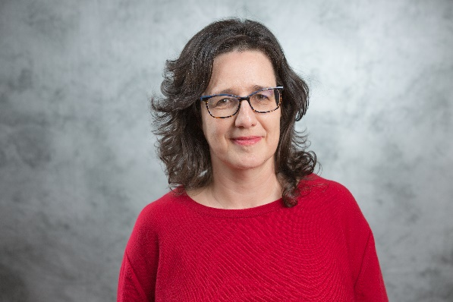
Prof. Daphna Hacker is a legal scholar and a sociologist, and holds a joint appointment at the Tel Aviv University Law Faculty and Women and Gender Studies Program. She is the Head of the Gender Studies Program and the Academic Advisor of the Elder Law Clinic at the Law Faculty.

Hacker researches and teaches with a focus on the intersection of law, families and gender. Her socio-legal studies provide empirical as well as normative insights in relation to singlehood and gender, post-divorce parental arrangements, inheritance conflicts, filial piety, and transnational families.

Prof. Hacker has published numerous articles in leading legal and socio-legal journals, including Law and Social Inquiry, Harvard Journal of Human Rights, Cornell Law Review, and International Journal of Law in Context. She is also the author of three books, the latest, recently published by Cambridge University Press, is titled Legalized Families in the Era of Bordered Globalization, and was the 2018 Best Book Award by the American Law & Society Association. She has received numerous grants and prizes, including two research grants from the Israel Science Foundation (2009-2011; 2015-2017) and a nomination to the Israeli Academy of Science Young Scholars in Humanities and Social Science Forum (2010).

Prof. Hacker is also highly involved in promoting women’s rights, and currently is the Chair of the Steering Committee of the Knowledge Center on Women and Gender, on behalf of the Science Ministry. For her public service on behalf of women, she has been given the Katan Award for the Advancement of Gender Justice through Voluntary Work (2013).

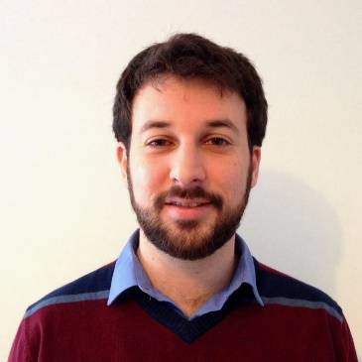
Dr. Isaac Sasson is a faculty member of the Department of Sociology and Anthropology and the Herczeg Institute on Aging at Tel Aviv University. His research addresses key questions about the social determinants of human longevity: How long will we live? Why do social inequalities in length of life persist? And why is life expectancy declining in the United States? Isaac’s work has been published in leading scientific journals, including Science, PLOS Medicine, Demography, The Journals of Gerontology, and Social Science & Medicine.

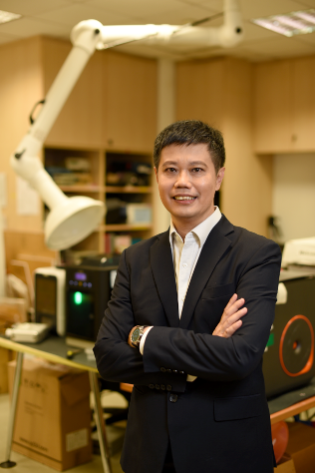

Kelvin Tan is Director of Corporate Partnerships at NUS Enterprise and also Director of Business Development for Smart Systems Institute (SSI). SSI is a leading NUS institute for advanced data analytics and AI research partnerships with TsingHua University, ZheJiang University, Southampton University and Keio University.

He is identified with co-developing corporate accelerator programs with Spore Airline (Aviation), Bayer Grants4Apps, Loreal Startup Runway, Defence Science Technology Agency, Mercedes Startup Autobahn, Huawei i5Lab (IoT) and Symphony Creative Systems of NYK Japan (Shipping) as well as innovation challenges with Danone, MundiPharma, Maybank, Ericsson ONE Challenge, Shell IdeaRefinery, P&G, Microsoft, SMRT, Ikea and THero of Guangzhou, China.

For the last four years, he was the NUS Enterprise lead for Modern Aging Spore program which was funded by Ministry of Health and NUS Enterprise. It has seed-funded 10 startups in developing innovative services and products for the seniors. In research, he is involved with assistive technologies such as companion robots for cognitive impaired seniors. He has actively mentored startups with other industry partners and government agencies to improve the validation of such innovations for implementation. He has lectured and presented in the topic of Aging and Technology in Taiwan, Singapore, Vietnam and Hong Kong.

Prior to joining NUS, he founded an interactive multimedia startup with China partner and EDBI investment and held regional management positions in HP, AT&T, M1, ServTouch-WyWy and Telecoms Authority of Spore. He is advisor to People’s Association with community projects.

He is a PhD Candidate (HKU) and Student Fellow (Sau Po Center for Ageing, HKU), holds a Master in Gerontology (SUSS, Spore), MBA (Oklahoma City University) and BEng in Electronic and Communications (University of Manchester, UK).

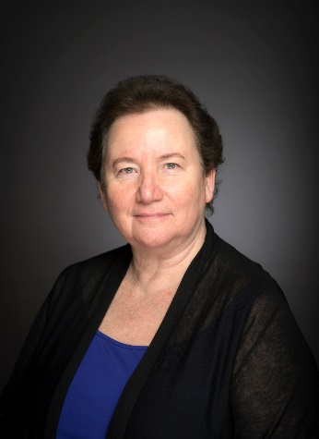
Dr. Dévora Grynspan, Vice President for International Relations, works closely with the President and other Northwestern leaders to advance the university's strategic goals in a global context and create greater integration between international programs and the university's strategic plan. In her role, Dévora Grynspan represents the president and the university to international constituencies; provides leadership and coordination in shaping and implementing the university's international agenda; and helps to design and administer partnerships, policies and programs that advance the global dimension of Northwestern's research and academic mission and advance the university's global footprint.

Dévora founded the former Office of International Program Development (IPD), which developed and administered student exchanges and specially designed study abroad programs for Northwestern students. IPD has since been merged with the Study Abroad Office to form the new Office of Undergraduate Learning. Over the past decade, she has established a number of programs abroad, including in China, Cuba, France, Germany, Israel, Mexico, Serbia and Bosnia-Herzegovina, South Africa and Tanzania. Dévora also co-founded Northwestern’s popular Program in Global Health Studies in 2004 and was its Co-Director until 2016.

Before joining Northwestern, Dévora taught at the University of Illinois in Urbana-Champaign, where she also directed the Center for Latin American Studies and established the Center on European Union Studies.

Dévora earned her bachelor’s, master’s and doctoral degrees at Northwestern and later received a law degree from the University of Illinois at Urbana-Champaign. Dévora was born in Israel and grew up in Costa Rica. She speaks fluent Spanish and Hebrew.

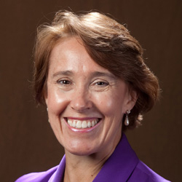
Dr. Dana Burr Bradley is Dean of the Erickson School and a Professor at UMBC. Her primary role is to lead the Erickson School in its mission of creating new knowledge, leaders, and opportunities in the longevity economy. A graduate of Carnegie-Mellon University (as a Rockefeller Humanities Fellow), Dr. Bradley has worked at UNC Charlotte, Duke and Western Kentucky University.

Dr. Bradley's research involves questions surrounding creating capacity for policy and service initiatives in aging across space and time. Current work involves questions of innovations necessary to sustain the longevity economy including workforce and technology. A leader in the Age-Friendly Cities movement she worked with the City of Bowling Green, KY in its work on Age-Friendly Cities. Internationally, she has focused on issues of long-term care and the longevity economy in Asia and most recently completed the first phase of work on transnational caregiving in New Zealand. An engaging and energetic speaker, she has worked with Fortune 500 companies to bring evidence-based strategies to improve the lives of elders and their families in the workplace.

Dr. Bradley believes that leadership, which means suggesting "the possible" and crafting an environment of "the probable," is important to her. Most recently she served as the Treasurer for the Academy of Gerontology in Higher Education and has served as President of the Southern Gerontological Society (SGS) and Secretary, the Gerontological Society of America (GSA). She is an elected fellow of The Gerontological Society of America and the Academy of Gerontology in Higher Education.
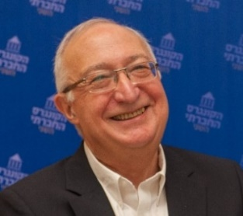
Prof. (Emeritus) Manuel Trajtenberg has been a Professor of Economics at Tel Aviv University since 1984, after receiving his Ph.D. at Harvard University. He has held visiting positions at Harvard and Stanford, is a Research Associate of the NBER in Cambridge, USA, and of the CEPR in London. He has contributed extensively to the economics of innovation, patents, R&D policy, growth and development, and is regarded as one of the world leading experts in the field of R&D and innovation. In the last decade, Trajtenberg held senior positions in government: founder and first Chairman of the National Economic Council at the Prime Minister’s Office (2006-09); Chairman of the Budgeting and Planning Committee of the Council for Higher Education (2009-14); Chairman of the government Committee for Social and Economic Change following the mass social protests in Israel in the summer of 2011; member of the Knesset, the Israeli Parliament for the Labor Party following the May 2015 elections – in October 2017 he resigned from the Knesset and returned to academia. Trajtenberg currently leads a policy-oriented project named “the first 100 days – a 21 st century socio-economic agenda for progressive governments” supported by the Samuel Neaman Institute at the Technion.

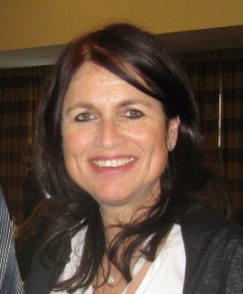
Dr. Hedva Voliovitch is a physician, board certified in internal medicine in Israel. She has worked as a practicing physician for 20 years, holds a Ph.D. degree in molecular biology from the Weitzmann Institute in Rehovot, and an M.B.A. with a specialization in global management from the Interdisciplinary Center at the Arison School of Business in Herzliya. She joined Teva Pharmaceutical Industries, Ltd in 1997 in order to establish the Global Pharmacovigilance unit, an independent unit in Teva which is responsible for defining and implementing patient safety policies and systems and ensuring compliance with global and local regulations in all Teva markets worldwide. She was appointed as Senior Vice President of Global Patient Safety & Pharmacovigilance in 2015 and managed approximately 450 PhV employees all over the world, most of whom are physicians, pharmacists and nurses. Since January 2018, she has served as a Member of the Board of Directors for the Trust Fund for Israeli Elementary and Preschool Teachers as well as a Member of the Board of Directors for the Trust Fund for High School Teachers and Supervisors.
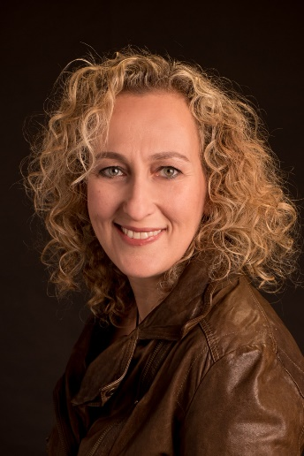
Miri Polachek has over 20 years of international leadership experience and passion in the healthcare industry. Polachek is currently CEO of Joy Ventures. Previously, she co-founded and led the Peres-inspired non-profit organization Israel Brain Technologies, which fostered and supported the entrepreneurial braintech community through its prestigious and internationally-recognized programs, and positioned Israel as a leading global brain technology hub. Before IBT, Polachek held financial management roles in the US and Israel in multinational and publicly traded healthcare companies including Pfizer and Teva. She holds a BA in Economics and Mathematics and MA in Health Economics from Boston University, as well as an MBA from New York University Stern School of Business.

